# Custom Classes

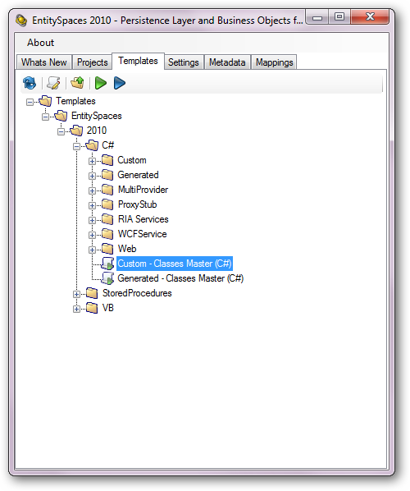

# Custom Classes – Basic Information Tab

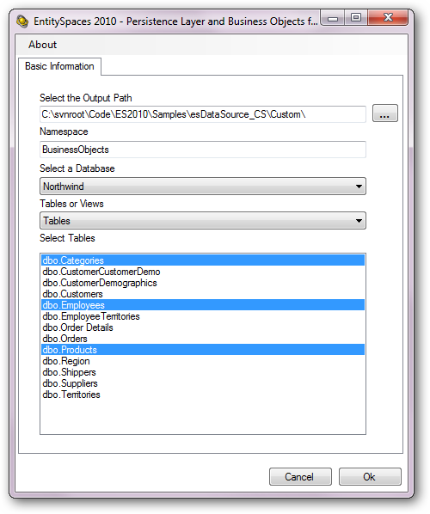

# Generated Classes

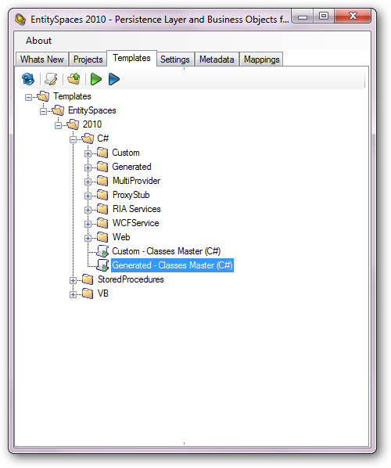

# Generated Master – Basic Information Tab

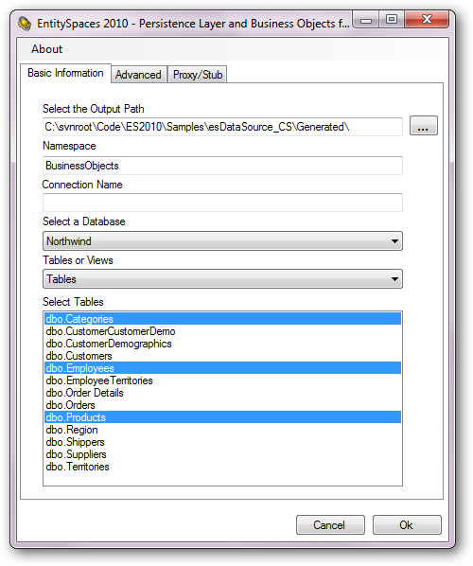

# Generated Master – Advanced Tab

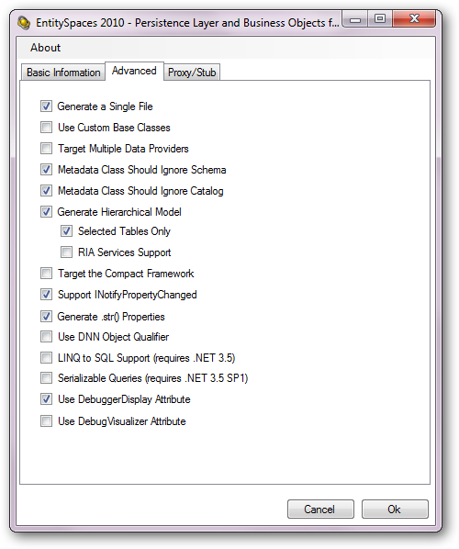

There was no need to use the Proxy/Stub tab for the ASPX esDataSource Application.